**Data Flow Diagram & User Stories**

|  |  |
| --- | --- |
| Date | 19 October 2022 |
| Team ID | PNT2022TMID41928 |
| Project Name | Real time River water quality monitoring and control system |
| Maximum Marks | 4 Marks |

DATA FLOW DIAGRAM:

A Data Flow Diagram (DFD) is a traditional visual representation of the information flows within a system. A neat and clear DFD can depict the right amount of the system requirement graphically. It shows how data enters and leaves the system, what changes the information, and where data is stored.

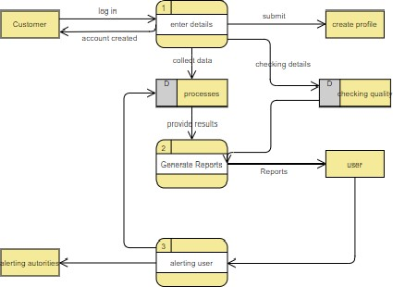

**User Stories**

|  |  |  |  |  |  |  |
| --- | --- | --- | --- | --- | --- | --- |
| **User Type** | **Functional**  **Requirement (Epic)** | **User Story**  **Number** | **User Story / Task** | **Acceptance criteria** | **Priority** | **Release** |
| Customer  (Mobile user) | Registration | USN-1 | As a user, I can register for the application by entering email, password and confirming my password. | I can access my account/dashboard | High | Sprint-1 |
|  |  | USN-2 | User will receive a confirmation email once I have registered for the application | I can receive a confirmation email &  click confirm | High | Sprint-2 |
|  |  | USN-3 | As a user, I can register for the application through Google | I can register & access the dashboard with Google | High | Sprint-1 |
|  |  | USN-4 | As a user, I can register for the application through Gmail | I can register through the mail. | Medium | Sprint-2 |
|  | Login | USN-5 | As a user, I can log into the application by entering email, password & captcha | I can receive login credentials. | High | Sprint-1 |
|  | Interface | USN-6 | As a user, the interface should be user-friendly manner | I can able to access easily. | Medium | Sprint-1 |
| Customer (Web user) | dashboard | WUSN-1 | As a web user, I can access the specific info (ph value, temp, humidity, quality). | I can able to know the quality of the water. | High | Sprint-1 |
| Customer Care  Executive  (input) | View manner | CCE-1 | As a customer care, I can view data in visual representation manner(graph) | I can easily understand by visuals. | High | Sprint-1 |
|  | Taste | CCE-2 | As a customer care , I can able to view the quality(salty) of the water | I can easily know whether it  is salty or not | High | Sprint-1 |
|  | Color visibility | CCE-3 | As a customer care , I can able predict the water  Color | I can easily know the condition by color | High | Sprint-1 |
| Administrator | Risk tolerant | ADMIN-1 | An administrator who is handling the system should update and take care of the application. | Admin should monitor the records properly. | High | Sprint-2 |